# Inventory Vouchers:

Inventory Vouchers performs the same function in the inventory system as accounting voucher do. They are the means by which you enter transactions relating to the Inventory. The vouchers record transactions relating to the issue and receipt of stock, the transfer of stock between good owns, and physical stock adjustments. The following inventory vouchers are available: 1) **Purchase Order (alt+f4)** 2) **Stock Journal (alt+f7)** 3) **Sales Order (alt+f5** 4) **Delivery Note (alt+f8)** 5) **Rejections Out (alt+f6)** 6) **Receipt Note (alt+f9)** 7) **Rejection In (ctrl+f6)** 8) **Physical Stock (alt+f10).**

*Steps to go to Inventory Vouchers:*

## Go to Gate way of Tally>ALT+F3>Inventory Vouchers.

**Purchase order**

Purchase order has to be made in the books of the company to assist them in checking whether the goods have been received or not. The purchase order number can be used as a reference. For example, the company wishes to place an order with the supplier for some goods.

## Sales Order (alt+f5)

When the order is received from a customer for goods to be supplied, the Items, quantities, date of delivery, etc., details are given with Sales Order Number. Later when these goods are delivered, this Sales Order is tracked for the order Details either in the delivery note or in the sales invoice.

## Rejections Out (alt+f6)

A rejection out entry is passed to record the rejected goods. This is a pure inventory voucher. For example: we have purchased some goods and have rejected a part of it.

# Sales Order

Description Records order details Details Recorded Customer’s ledger account, Name and Address, Order details, Name of stock item, Due on, Godowns, Quantity, Rate, Amount, Narration.

**Rejection Out** (Purchase return) Description Records rejected stock details returned to suppliers. Details Recorded Ledger account, Suppliers name and address, Order details, Stock item, Tracking details, Godowns, Quantity, Rate, Amount, Narration. Rejections In (ctrl+f6) A rejection in entry is passed to record the rejected goods. The Rejection In entry is a pure inventory voucher. For example: a costumer has rejected goods that was sold earlier.

**Stock Journal (alt+f7)** To record the consumption of goods there is no need for entries in both sides of the voucher. Such entries can be entered in a stock journal voucher. For example: the company transfers the items of stock from the warehouse to shop.

**Delivery Note (alt+f8)** Goods that are being delivered to a customer in a Delivery Note Voucher.

# Receipt Note (alt+f9)

Goods that are received from the supplier are recorded in a Receipt Note (Goods Receipt Note – GRN) voucher.

**Rejection In (Sales return)** Description Records rejected stock details received from customer. Details Recorded Ledger account, Customer name and address, Order details, Stock item, Tracking details, Godowns, Quantity, Rate, Amount, Narration.

Stock Journal Description Essentially records the transfer of stock from one Godowns to another. Details Recorded Names of from and to godowns, Name of stock item, Godowns, Quantity, Rate, Amount, Narration.

Delivery Note Description Records delivery of new stock to customers. Details Recorded Reference, Ledger account, Suppliers(if supplementary details are set to yes in f12: Delivery Note Configuration)then, name and address, Order and dispatch details, Name of stock item, Order details, Godowns, Quantity, Rate(optional), Amount(optional), Narration.

Receipt Note Description Records receipt of new stock from supplier. Details Recorded Reference, Ledger account, Suppliers(if supplementary details are set to yes in f12: Delivery Note Configuration)then, name and address, Name of stock item, Order details, Godowns, Quantity, Rate(optional), Amount(optional), Narration.

**Physical Stock Voucher (alt+f10)** It consider the stock available based on the entry made in a physical stock voucher. For example: on conducting a stock, the company finds a discrepancy between the actual stock and the recorded stock figure.

## Entering different consumption and production of company.

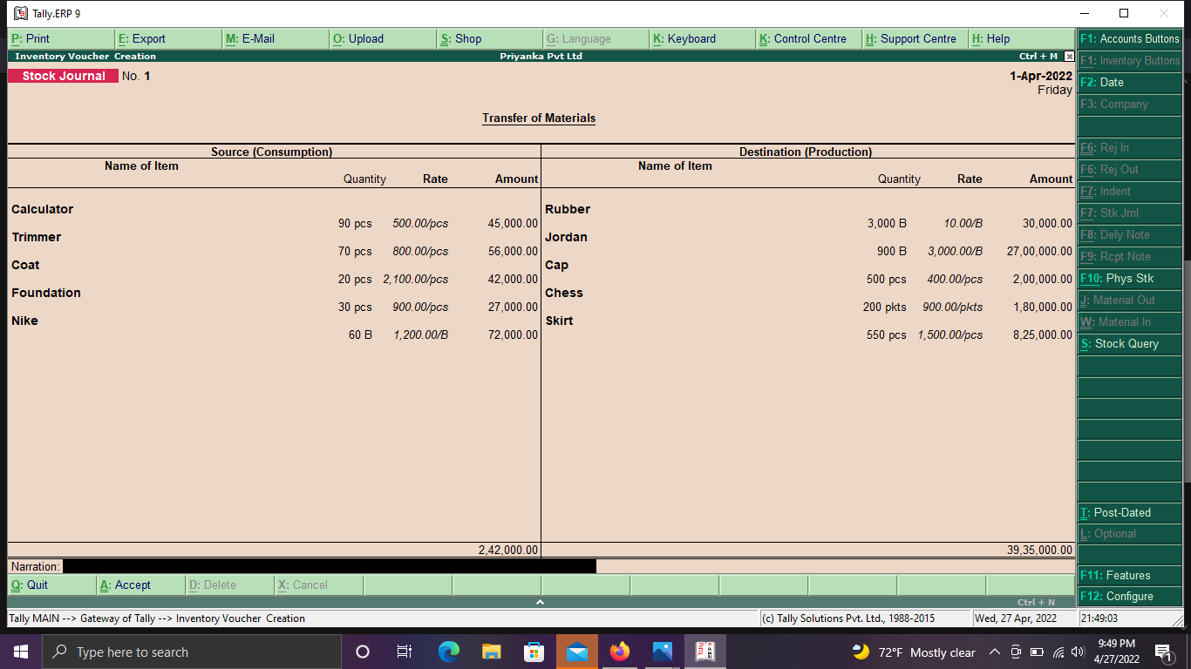

**Trail balance of Priyanka PVT LTD.**

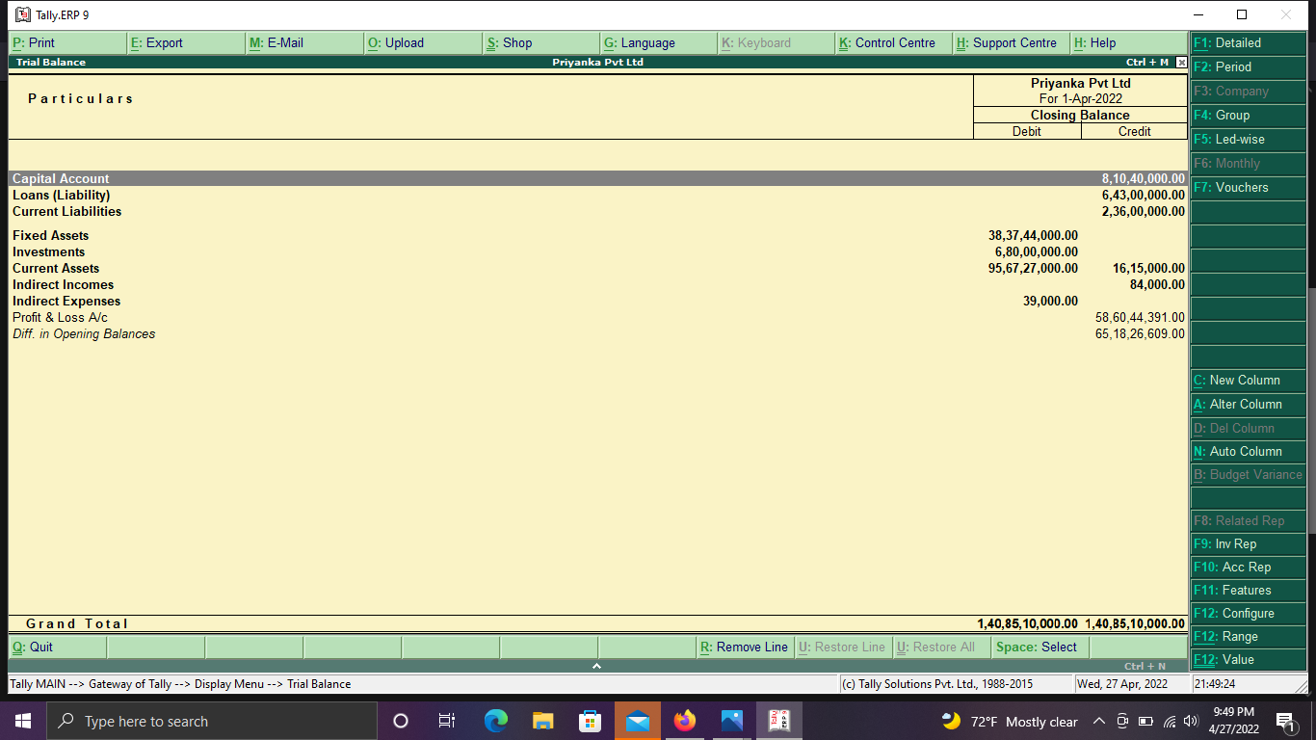

## Cash and bank book of Priyanka PVT LTD.

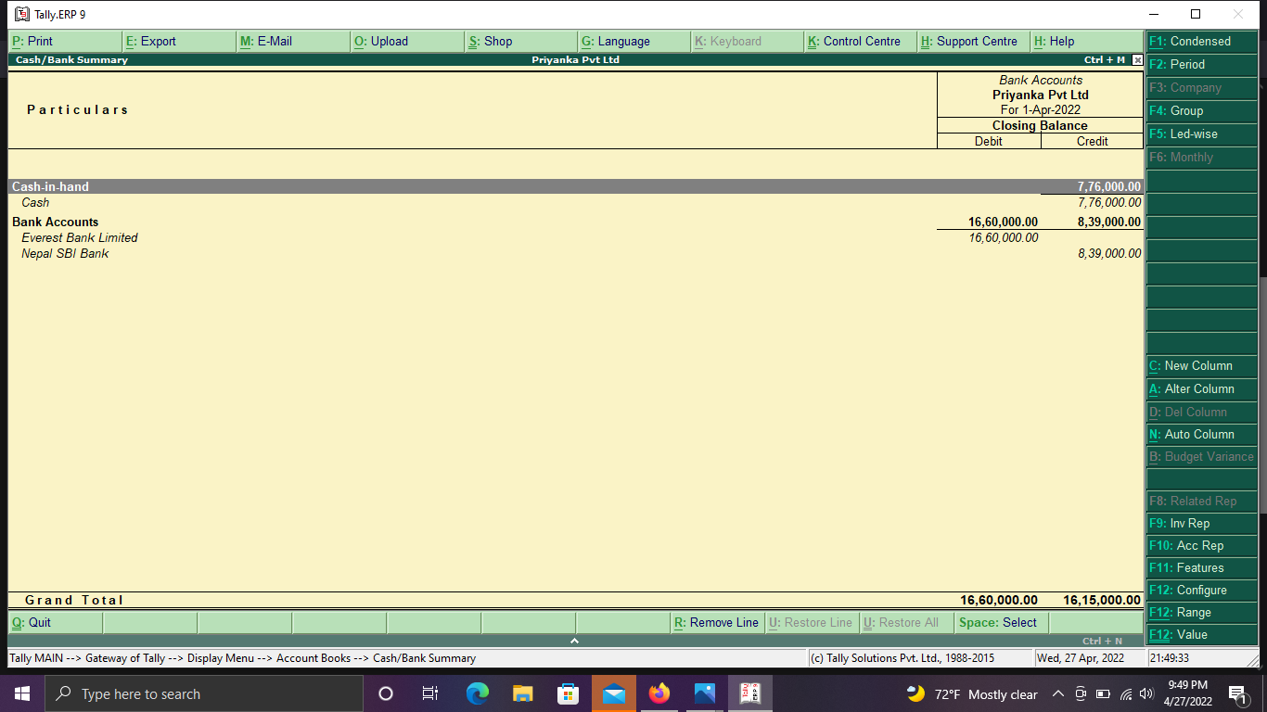

**Sales register of April month in Shubham PVT LTD.**

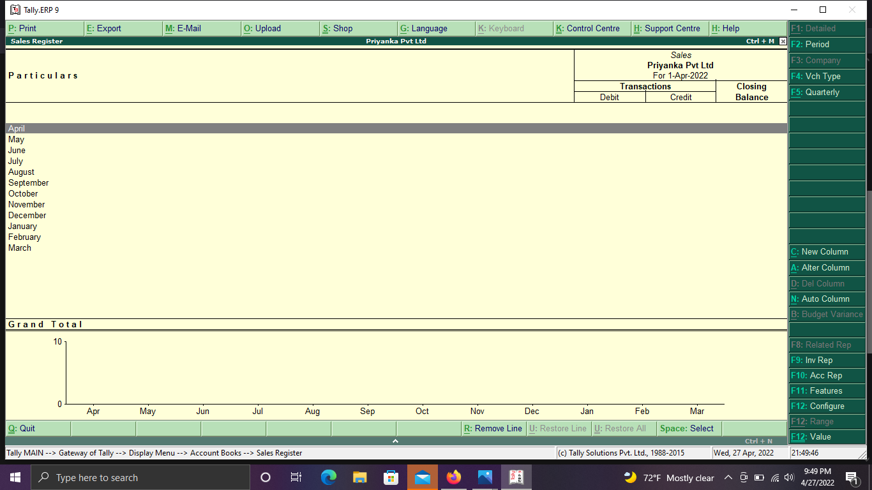

## Statistics of different accounts

## 